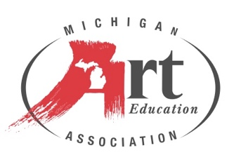

**2025 MAEA Museum Art Educator of the Year**

**Meghan Collins** is an art museum educator who thrives on building connections and community through her work at the MSU Broad Art Museum. She loves working with art educators to expand their curriculum to include global contemporary art, and leads a group of undergraduate students who facilitate the museum’s youth and family programs. Meghan wants everyone to experience the wonder and curiosity of meeting an artwork and allowing it to teach them something new about themselves or the world around them.

Meghan received her BFA in Art Education at Michigan State University and her MA in Art Education from Maryland Institute College of Art. Prior to working in an art museum, Meghan was a K-8 art educator in Michigan and Maryland.